Code for plotting Chinese against HydroSense- Plateau

#Kluane Gradient Moisture####

temp<-read.csv("scripts/users/hthomas/Data/Tea/Env.Vars/Kluane_Moisture/Plat_Moisture_Data.csv")

temp<-temp[,c(1:6)]

temp$Date<-as.POSIXct(temp$Date,format="%d/%m/%Y")

temp$Date<-temp$Date + years(2000) #correct years

names(temp)[4]<-"Moisture.Orig"

temp$Plot<-paste(temp$Site,temp$Treatment,sep="")

#Extract dates for which both

cal.data<-subset(temp,Date=="2016-08-13")

#Predict chinese sensor variables

#Currently no overlap

cal.data<-cal.data %>%

  group_by(Plot, Probe.Type) %>%

  summarise(Moisture.Orig = mean(Moisture.Orig)) %>%

  spread(Probe.Type,Moisture.Orig)

y<-cal.data$HydroSense

x<-as.numeric(as.character(cal.data$Chinese))

fit <- lm(y ~ x)

temp2<-subset(temp,Probe.Type=="Chinese")

temp<-subset(temp,Probe.Type=="HydroSense")

temp$Moisture<-temp$Moisture.Orig

temp2$Moisture<-(predict(fit, list(x=temp2$Moisture.Orig)))[1:122]

temp<-rbind(temp,temp2)

#Check what it looks like

ggplot(temp,aes(Plot,Moisture,colour=Probe.Type))+

  geom_boxplot()

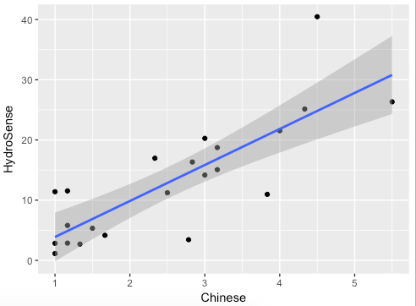

Relationship is good when line is straight.